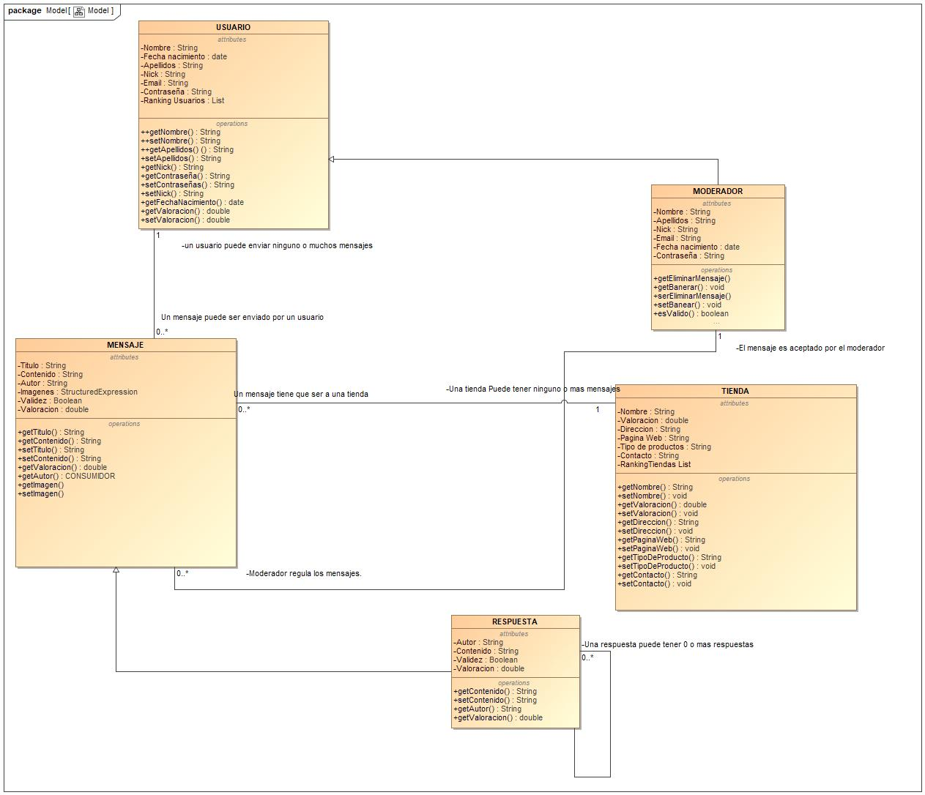

Diagrama_de_clases
Class Specification Report
Author: Author
Revision: 0.2

No Magic
One Allen Center, 700 Central Expressway South, Suite 110 Allen, Texas 75013 USA | junio 02, 2020

Approval
The original of this document is approved and signed by:
Name:
Surname:
Title:
Date:

Signature:
Revision History
Revision | Date | Description | Author
0.1 | <date 1> | <draft> | <Author name>
0.2 | <date 2> | <release> | <Author name>

Table of Contents
Figure 1.Introduction 5
Purpose 5
Scope 5
Overview 5
Figure 2.Appendix A: Diagram 6
Model 6
Figure 3.Model 6

Table of Figures

Introduction

Purpose
This document provides class, interface, and enumeration specification. The specification provides the details of the types being modeled within the system

Scope
This document is intended to define class specification for the {System Name}.

Overview
This document provides a list of all packages with a summary for each. Each package has a section that contains a list of its classes, interfaces and enumeration type, with a summary for each. Class and Interface contains description, summary tables, detailed member descriptions, and relation table.

Appendix A: Diagram

Model

- Model

